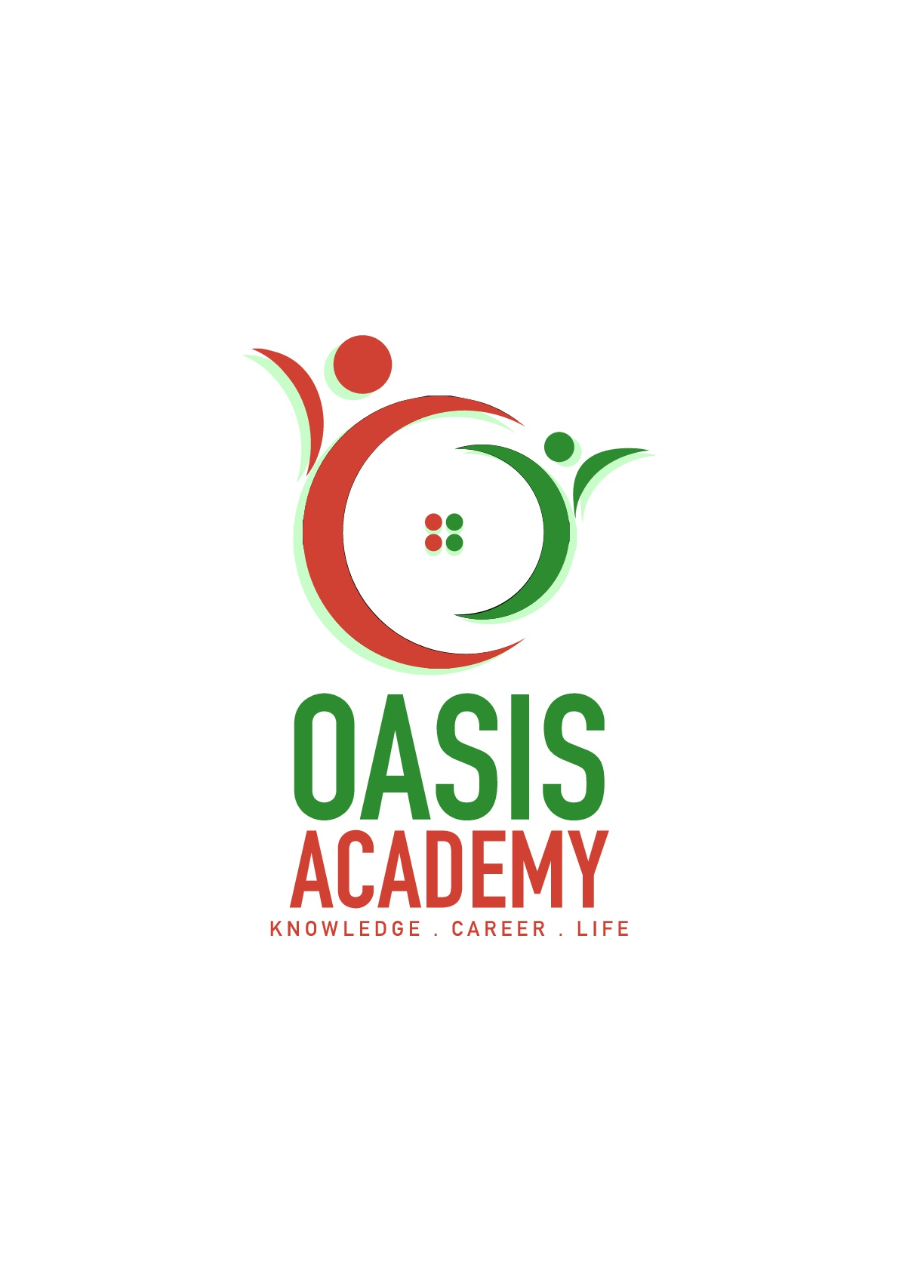

Name: Ruben Goh Sen Lee

Login ID: ruben@oasis-portal.com

Course title: Essentials on Human Resources

Subject Code: BHM01

Submitted date:

**Table of Contents**

|  |  |  |
| --- | --- | --- |
| **No** | **Details** | **Page** |
| 1 | Executive Summary | 3 |
| 2 | Introduction | 4-5 |
| 3 | Assignment Question |  |
|  | Part 1 | 6-9 |
|  | Part 2 | 10-13 |
|  | Part 3 | 14-15 |
|  | Part 4 | 16-18 |
| 4 | Conclusion | 19 |
| 5 | References | 20 |
|  | Appendix |  |

**Executive Summary**

In this assignment, I will be explaining about my understanding on Human Resource Management (HRM) and the importance of HRM. HRM plays a very crucial role in every organization, big and small, as they are in charge of managing, recruiting and motivating their staff and employees in order to achieve the company's goal. HRM not only manage, recruit and motivate but do more on a weekly basis which I will be describing below. Firstly, I will explain and describe the major activities and human resource operation in hospitality management. Secondly, I will describe briefly on human resource planning and planning trend in hospitality. In addition, I will elaborate my understanding on action plan human resource planning in hotel industry. Thirdly, I'll brief about human resource functions and human resource policies. Furthermore, I'll describe the functions of management and how the policy applies accordingly in hospitality management. In the final part, I will give a detailed explanation about organizational behavior in hospitality and brief on groups and structures in organization.

**Introduction**

In this assignment, I will give my understanding and my elaboration on the essentials of human resources and the importance of human resources. In this assignment, I will explain with detail about human resource management in hospitality, how human resources manage one another in a systematic way. Furthermore, I'll also describe how the functions of management and policies applies accordingly in hospitality management. Lastly, I will give a detailed explanation about organizational behavior in hospitality and brief on groups and structures in organization. Human resources plays a major part in every company big and small as they carry out all the tasks needed. Human resources consists of many people working in unity. For an example, Singapore has one of the highest number of human resource in the world that consists of not only chinese but races

from different countries such as indians, malays, russians, hispanics and many others.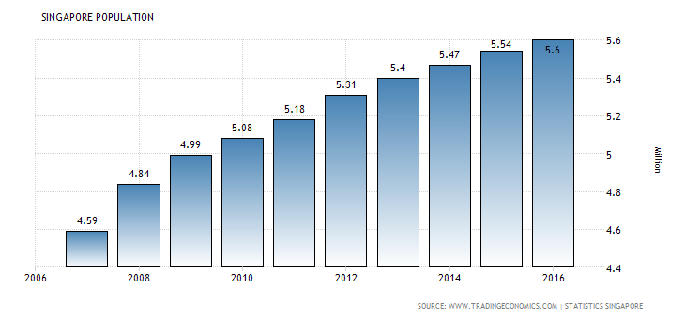

Above is the population chart of Singapore where the population represents 0.08 percent of the world's which means one person in every 1346 people on the planet is a resident in Singapore. Most of the people that comes to Singapore are mainly from China and the second most comes from India. As the years pass, more and more people will continue coming to Singapore from every parts of the Earth.

**Assignment Questions**

**Question 1**

Define the Major Activities and Human Resources Operation in Hospitality Management.

Hospitality management is a service industry where they provide services to meet the customers' needs. Providing satisfactory service to customers is one thing but finding the staff capable of providing said staff is harder but because of the major activities and human resources operation, it has become an easy procedure to follow. Below are the procedures on how the human resources operations carry out major activities.

Recruiting

There are many methods used in recruiting candidates that will help contribute to the company. Most activities of recruitment are done at locations the most ideal candidate would be. Example, those who have recently graduated from colleges or universities or those that come from nonprofit organizations. Some of the methods used are advertisement where they use social media such as Facebook, Twitter, flyers and various ways to attract potential future employees with various personal skills that will apply for the job opening. Recruiting is done through interview sessions between the employer and candidates so that the employer is able to assess the candidate in person.

Selecting

The selection process is an important major activity because of the production and performance value companies get by making good hires and the high costs of replacing employees following bad hires. The selection process developed by human resource professionals is planned strategically and implemented by organization when evaluating and hiring new employees. Along with finding the best hire, cost efficiency and legal concerns are two main reasons why the HR selection process is so important. When the company makes a bad hire, they pay to train and orient a person who will ultimately cause more harm than good when he or she performs poorly and negatively affects the workplace.

Training

Training helps the company to keep the right people with the right requirement and grow even more profit with said people. The aim of training employees is to develop the skills of employees so that they are able to do their assigned tasks more efficiently and more quickly. Training also helps to analyze the skills and abilities of the employees and assigning tasks more suited to the skills and abilities of the employees. The time needed for training new employees are usually between two weeks and a month. The advantage of training help the company to increase profit, reduce employee turnovers and deeper talent succession pipelines. The advantage of training also helps increase the employee motivation and improve their speed to competency.

Motivation

Motivation plays a heavy part in employees' performance in work. If motivation is kept at an all-time high, the performance of employees will indefinitely increase the profits gained by the company. A motivated worker means a highly productive staff that will help the company achieve it's business goals

Evaluation

The purpose of employee evaluation is to measure job performance, strengths and weaknesses of employees. Employee evaluations are needed to reveal to them their weaker capabilities in their work and what to improve on and what they need to do to improve on. Because of this, employees will be able to develop and hone their skills and abilities to an efficient level.

Compensation

Compensation(also known as Total Rewards) can be defined as all of the rewards earned by employees in return for all their hard labor. There are three types of compensations. Direct financial compensation which consists of pay received in the form of wages, salaries, bonuses, and commissions provided at regular and consistent intervals. Another is Indirect financial compensation which includes all financial rewards that are not included in direct compensation and understood to form part of the social contract between the employer and employee such as benefits, leaves, retirement plans, education and employee services. Lastly, non-financial compensation which refers to topics such as career development and advancement opportunities, opportunities for recognition, as well as work environment and conditions.

**Question 2**

Describe in brief on Human Resources Planning and Planning Trend in Hospitality.

Human Resource Planning is a type of process that knows what its current and future human resources needs. A process that knows which is the right employee for the right job that is available at the right time. It aims to maintain the HR needs of the organization. It is also a process that not only focuses on the people themselves but also takes in consideration of their working conditions and relationship in which they work.

Explain about what is your understanding on Action Plan Human Resource Planning in Hotel Industry.

Human Resource planning is a process through which the right person for the right job is ensured. For any major steps to be taken, the foremost essential task for the human resource management is to develop the organizational objective to be achieved through conducting the said major steps. There are six steps in Action Plan Human Resource Planning in Human Industry.

Analyzing Organizational Objectives

The objective the hospitality organization needs to recognize and achieve in future in various fields such as production, marketing, finance, expansion and sales.

Inventory of Present Human Resources

To fill out the various job requirements in the Hospitality industry, human resource management will need to analyze the current number of employees, their capacity, performance and potential based on up-to-date human resource information storage system. This is one of the ways to maximize satisfaction of service.

Forecasting Demand and Supply of Human Resource

The human resources required at different positions according to their job profile are to be estimated. The available internal and external sources to fulfill those requirements are also measured. There should be proper matching of job descriptions and job specifications of one particular work and the profile of the person that is suitable for the job.

Estimating Manpower Gaps

A comparison of human resource demand and human resource supply will provide the organization with the surplus or deficit of human resource. Deficit represents the number of people to be employed, whereas surplus represents termination of human resource. Extensive use of proper trainings and development programs can be initiated or done to upgrade and improve the skills and abilities of employees.

Formulation The Human Resource Action Plan

The human resource plan depends on whether there is deficit or surplus in the organization. Accordingly, the plan may be finalized either for new recruitments, training, interdepartmental transfer in case of deficit of termination, or voluntary retirement schemes and redeployment of old employees in case of surplus.

Monitoring, Control and Feedback

This mainly involves the implementation of the human resource action plan in hospitality. Human resources are allocated according to the requirements needed, and inventories that are updated over a set period. The plan is monitored strictly to identify the deficiencies and to remove it. Comparison between human resource plan and its actual implementation is done to ensure the appropriate actions that are taken and the availability of the required number of employees needed for various jobs. Example of this would be if an outlet of the organization is short on staff, they will assign extra staff from other outlets to the outlet that is short-staffed

**Question 3**

Brief about Human Resource Functions and Human Resource Policies.

There are four types of human resource functions. Firstly, planning function which includes setting of goals and objectives and finding out various ways and methods to achieve said goals and objectives. Secondly, organizing function which the designing of jobs, ideas, structures and systems to achieve objectives and goals. Thirdly, directing function that includes leading and motivating people for the attainment of objectives and goals. Lastly, controlling function which includes maintaining the deviations from plans and then evaluating the levels of attainment of goals.

Human resource policies are guidelines on the approach an organization intends to adopt in managing people. Human resource policies are instructions that will guide HR managers on various matters such as employment, recruitment, promotion, compensation and training. They therefore serve as a reference for when human resource management practices are still in development or when heavy decisions are carried out by the organization. The purpose of human resource policies helps organizations, big or small, to show, internally and externally, that it meets requirements for diversity, ethics and training as well as its commitments in relation to regulation and corporate governance of its employees.

Describe the Functions of Management and How the policy applies accordingly in Hospitality Management.

Functions of management in hospitality are split into four parts which are planning, organizing, leading and controlling. Firstly, planning in management is the conscious determination of future course of action that involves why in action, how to take action and when to take action. Secondly, organizing or implementation making optimum use of resources required to enable the successful carrying out of plans. Thirdly, leading in management that determines what needs to be done in a situation and getting people to do it. Lastly, controlling or monitoring in other words, which includes checking of progress against plans which may need modifications based on feedback to better the service provided.

Policies that apply to the hospitality industry varies as there are many different organizations under hospitality. For some hospitality organizations, they adopt the policy for employee satisfaction as it helps to motivate the employees through communication and to easily solve the problems of employee which will help in organization development. It also includes employee promotions and benefits such as bonuses. Employee promotions are based on performance of said employee. Policies are also applied as they help to better control each management with ease and less issues are made. Reducing internal problems as much as reducing external problems.

**Question 4**

Explain in detail about Organizational Behavior in Hospitality and brief on Groups and Structure in Organization.

Organizational behavior is a type of field study that investigates the impact that individuals, groups and structures have within an organization. It comprises of a group of people with different backgrounds working together within an organization applying the best of their knowledge and skills for the sake of the organization. Organizational behavior includes four factors which are psychology, sociology, anthropology and political science.

Psychology

Psychology is a type of knowledge, a study and applied regulation that involves study of human or animal mental functions and behaviors. It shows how individuals react when a problem, internal or external, emerges in the organization.

Sociology

Sociology is the study of society. It is a social science that uses various methods based on investigations and critical analysis to create and improve a knowledgeable body about human social activity, often with the objective of applying said knowledge to the pursuit of social welfare. Sociology shows how individuals relate to groups and one another which improves teamwork.

Anthropology

Anthropology shows an understanding towards custom traditions and social characteristics of people.

Political Science

An understanding on power, authority and corporate politics.

Organizational behavior is an important aspect in an organization as it helps to understand and predict future events, helps an individual to himself/herself in better fashion, helps managers to manage human resources effectively and many others.

Groups and structures in organization which is also known as organizational structure can be defined as how activities such as task allocation, coordination and supervision are directed towards the attainment of organizational aims. Organizations should be efficient, flexible, innovative and caring in order to achieve a sustainable competitive advantage. Groups and structures can also be considered as the viewing glass or perspective through which individuals see their organization and its environment. An organization is structured depending on the groups involved and its aims and objectives. The structure of an organization will determine the form in which it operates and performs. Organizational structure affects organizational actions in two ways. Firstly, it provides the foundation on which standard operating procedures and routines rest. Secondly, it shows which individuals gets to participate in which decision making processes and thus to what extent their views shape the organization's actions. (Wikipedia, 2017)

**Conclusion**

From what I have learned, no organization is able to function without human resources. Organizations needs human resources to carry out tasks, to manage its staff, to plan ahead for the organization and to achieve the goals of an organization. Because of human resources, organizations are able to expand and develop. Because of human resources, the organization's goals are within reach. The roles of human resources is indeed essential for an organization to be able to strive in terms of business.

**References**

1 Tradingeconomics ( 2017) (online) Singapore Population. Retrieved from:<http://www.tradingeconomics.com/singapore/population>

2 Hearst Newspapers, LLC(2017)(online) Chron. Retrieved from <http://smallbusiness.chron.com/six-main-functions-human-resource-department-60693.html>

3 Community Foundations of Canada (online) hrcouncil. Retrieved from<http://hrcouncil.ca/hr-toolkit/defining-compensation.cfm>

4 Hearst Newspapers, LLC (2017) (online) Chron. Retrieved from<http://smallbusiness.chron.com/four-basic-functions-make-up-management-process-23852.html>

5 Wikipedia(2017)(online). Human Resource Policies. Retrieved from<https://en.wikipedia.org/wiki/Human_resource_policies>

6 Wikipedia(2017)(online). Organizational Structure. Retrieved from<https://en.wikipedia.org/wiki/Organizational_structure>

THE END